  - Unit 4 Test Review: Angles
Outcome: SS6.1
- I am able to identify and classify angles in triangles and then connect this knowledge to measure angles in quadrilaterals.
- I am able to estimate and measure angles.
- I am able to draw angles.

- Using the picture below, list the numbered angles in order from least to greatest.

1
2
Level
1

3
1

3

Level
2

What is the measurement of this angle?
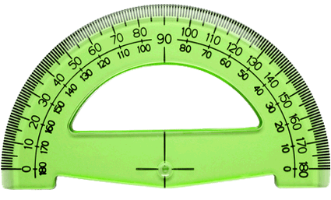
- Estimate the measure of the angles. Explain which referent angles you used. Tell whether each angle is acute, obtuse, straight or reflex. Give reasons for your choice of angles.
Level
3

- B.
- A student measured this angle and found it to be 115°. Do you agree? Explain your answer.

Level
4

- Measure and name the following angles and the lengths of each side. Describe the tools and process you used to find the measurements.

- Find the measures of the angles labeled m and n without the use of a protractor. Explain a strategy you used to find the answer.

Level
4

n
60°
m

122°
65°
m
n

- Draw 2 different quadrilaterals. Measure and record each angle. Find the sum of the measures for each quadrilateral.
Level
3

- Think about the angles formed by the hour hand and the minute hand on a clock, write a time when the angle is:
Level
4

- An acute angle ______
- A reflex angle ______
- An obtuse angle ______

- Determine if a quadrilateral can be drawn with the angle measures given. If it can be drawn, draw and label it.

- 110°, 66°, 134°, 50° b) 120°, 95°, 16°, 88°

- Is it possible to draw ΔPQR with these measures? Explain.

PQ = 5 cm
PR = 5 cm
QR = 6.5 cm
<Q= 45°
<R = 45°

Level
3

m
m
- A quadrilateral has three angles that measure 42°, 174°, and 29°. A student says the measure of the fourth angle is 115°. Is the student correct? Explain how you know.

