Name: ________________________

Percents Test Review

**Outcome:** N6.5Demonstrate understanding of percent (limited to whole numbers to 100) concretely, pictorially, and symbolically.

1. Write as a percent. Then write as a decimal.

|  |  |  |
| --- | --- | --- |
|  | percent | decimal |
| a) 24 out of 100 |  |  |
| b) |  |  |

2. Use this grid to answer the following questions.

|  |  |  |  |  |  |  |  |  |  |
| --- | --- | --- | --- | --- | --- | --- | --- | --- | --- |
|  |  |  |  |  |  |  |  |  |  |
|  |  |  |  |  |  |  |  |  |  |
|  |  |  |  |  |  |  |  |  | Level  1 |
|  |  |  |  |  |  |  |  |  |  |
|  |  |  |  |  |  |  |  |  |  |
|  |  |  |  |  |  |  |  |  |  |
|  |  |  |  |  |  |  |  |  |  |
|  |  |  |  |  |  |  |  |  |  |
|  |  |  |  |  |  |  |  |  |  |
|  |  |  |  |  |  |  |  |  |  |

a) What fraction of the grid is shaded? __________

b) What decimal of the grid is shaded? __________

c) What percent of the grid is shaded? __________

d) What fraction, decimal and percent are equivalent? *(Which of the values in a,b,c are equivalent? List them in a sentence.)*  ______________________________________________

___________________________________________________________________________

e) How are fractions, decimals and percents alike? *(explain in a sentence)* __________________

______________________________________________________________________________

3. a) **Estimate** the percent of the grid that is shaded. __________

b) Count the squares to check the **actual** percent. __________

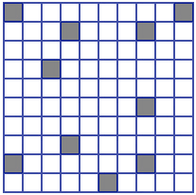

Level

2

4. Forty-four percent of children watch television before bed.

What percent do not watch television before bed?

|  |
| --- |
| Show your work. |

5. Write as a percent and a decimal.

a) ________ ________

b) ________ ________

6. Write as a fraction (*no need to simplify the fraction)* and a decimal.

a) 86% ________ ________

b) 40% ________ ________

7. What percent is shaded? *(Remember…a percent is out of 100)First,* *make an equivalent fraction with a denominator out of 100. Then turn into a percent.*

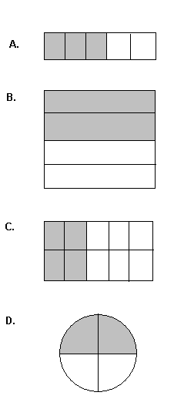

__________

Level

2

__________

__________

__________

8. Pittsburg played Montreal. Carry Price saved 36 out of 38. Mark Andre Fleury saved 91% of the shots.

Which goalie saved the greater percent of shots? _________________

Show your work here.

|  |
| --- |
| Level  3 |

9. Use the grid to show a decimal number and a fraction equal to 45%. Record the decimal number and percent below.



45% = ________ = ________

10. What percent of the stars are shaded? ____________

11. Make up your own comparison chart. For example, compare the number of coloured shirts students in our class are wearing. The numbers should be recorded as a percent (totaling to 100).

|  |  |
| --- | --- |
|  |  |
|  |  |
|  |  |
|  |  |
|  |  |
|  |  |

1. Make up one question that goes along with the results in your chart. If you need help, look at the next question (question #12).

__________________________________________________________________________________________________________________________________________________________

Answer your question: __________________

12. Use the data in the table.

The following is an approximate composition of the sun (numbers have been rounded off).

|  |  |
| --- | --- |
| **Gas** | **Percent**  Level  4 |
| Hydrogen | 92% |
| Helium | 7% |
| Oxygen | 0.05% |
| Carbon | 0.03% |
| All other Gases (Neon, Iron, etc.) | 0.02% |

Circle true or false. Show your work.

|  |
| --- |
| a) Less than 10% of the sun is composed of Helium. True or False |
| b) Of the gases, $\frac{8}{100}$ were gases other than Hydrogen. True or False |
| c) More than $\frac{3}{4}$ of the gases was Hydrogen. True or False |
| d) Less than 0.0001 of the gases was Carbon. True or False |